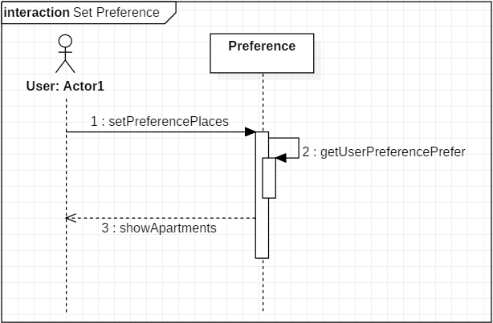

This sequence diagram describes how the client set their preferences for their apartment through our application.

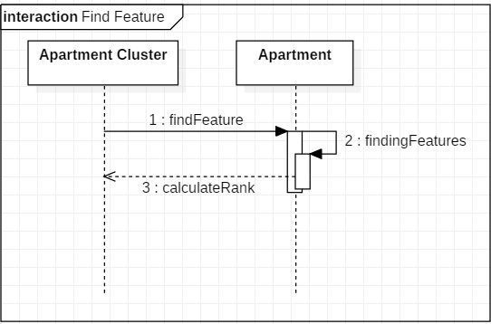

This sequence diagram describes how the application find the apartments for which features are set by client.